Arrays Demo

1. Start our program
   1. Start Visual Studio
   2. Create a new empty C++ project:
   3. Call it “ArrayDemo”, pick the desktop as the location and click OK.
   4. Click on Source Files and Add|New Item:

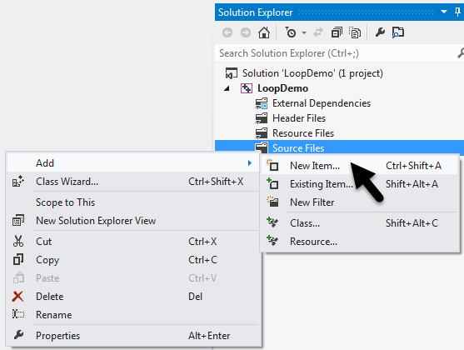

* 1. Select Visual C++, C++ File (.cpp), call it “ArrayDemo”, then click “Add”:

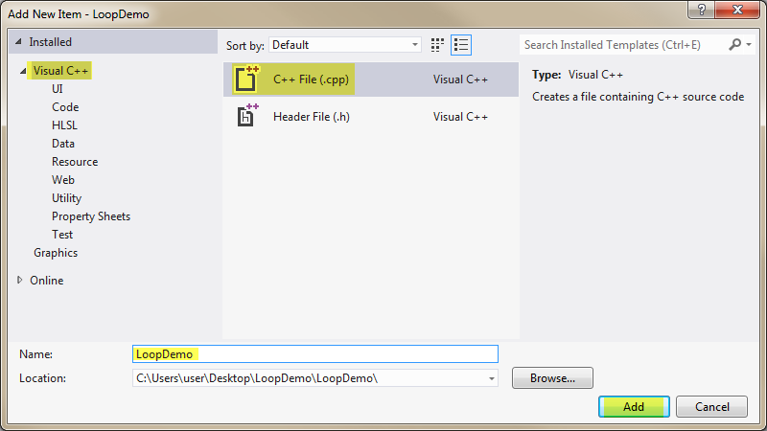

* 1. Enter the following code to start our program:

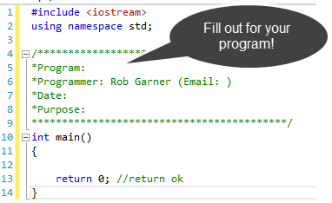

# Declare an array

* 1. Enter the following code:

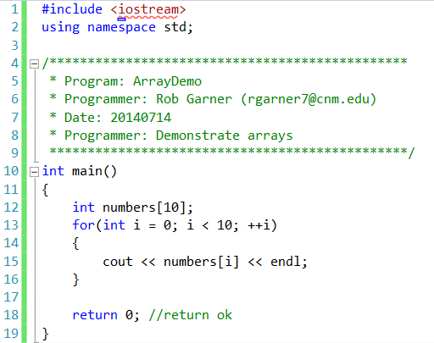

* 1. Try it with Ctrl-F5:

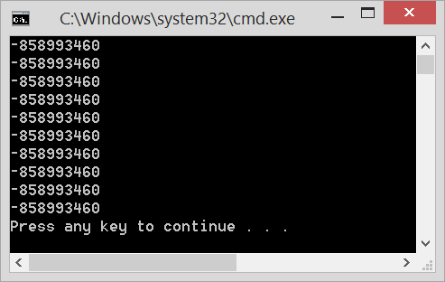

* 1. Notice that we get unpredictable numbers! Largest negative default.

# Initialize values using loop:

* 1. Change code to:

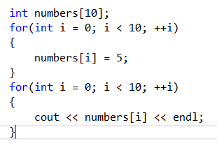

* 1. Try it with Ctrl-F5

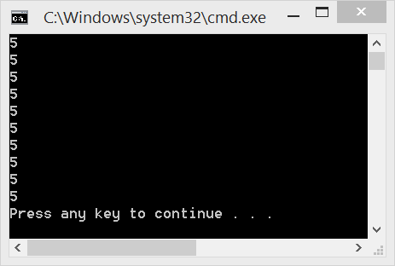

* 1. Notice that all values are set to 5.

# Show cube of each number:

* 1. Include cmath library in your program:

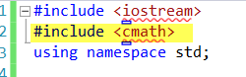

* 1. Change code to:

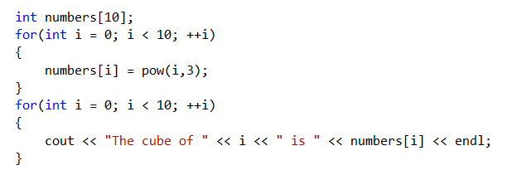

* 1. Run it with Ctrl-F5:

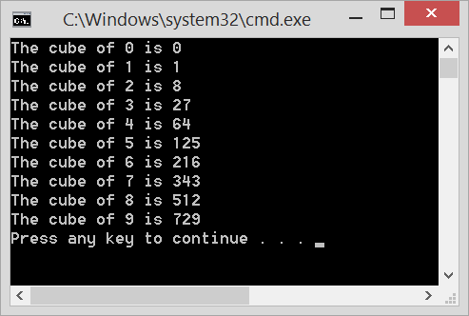

# Initialize arrays:

* 1. Change code to:

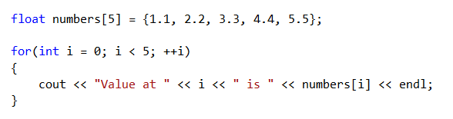

* 1. Run it with Ctrl-F5:

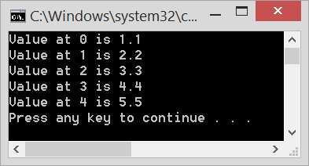

* 1. Notice that we are able to initialize to specific individual values.

# Initialize an array of strings

* 1. Change code to:

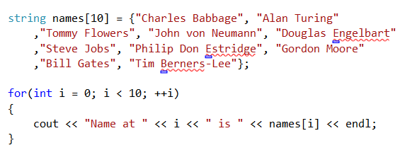

* 1. Test code with Ctrl-F5:

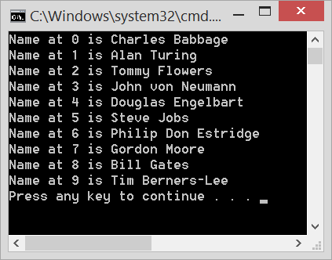

* 1. These are names of computer scientists. Look them up. Find out what their key contributions to computer science was.

# Array Out of Bounds

* 1. Enter the following code:

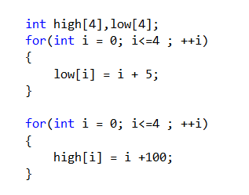

* 1. Try it with Ctrl-F5:

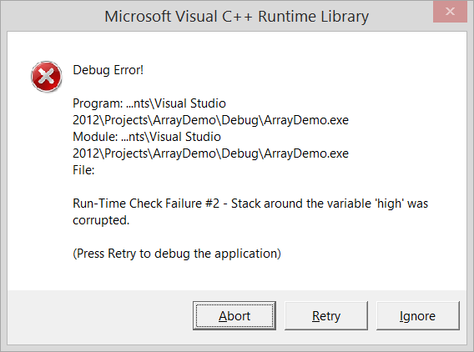

* 1. Notice you get an Error!
  2. What was wrong with the code?